THEORY OVERVIEW (for notes)
- DNS (Domain Name System): translates names like www.flipkart.com into IP addresses. It uses UDP port 53 (TCP for large responses).
- DHCP (Dynamic Host Configuration Protocol): automatically gives a device an IP address, subnet mask, gateway and DNS server. It works in four steps (Discover, Offer, Request, Acknowledge) over UDP ports 67 and 68.
- HTTP/HTTPS: the protocol browsers and apps use to request and receive web pages and data. HTTP uses port 80 and HTTPS (HTTP over TLS encryption) uses port 443.
- FTP (File Transfer Protocol): moves files between computers, using port 21 for control. It sends data in plain text, so SFTP or FTPS is used for security.
- SNMP (Simple Network Management Protocol): lets a management system monitor and manage devices such as routers and switches, over UDP ports 161 and 162.
REPORT: THE ROLE OF DNS AND HTTP IN WEB COMMUNICATION
When you type www.spotify.com into a browser, two protocols work together. People use names, but computers route traffic using IP addresses, so the first step is DNS. The browser asks a DNS resolver (usually your router or the ISP’s server) for the IP address of the name. If the resolver doesn’t already have the answer cached, it queries other DNS servers (root, top-level domain and the site’s authoritative server) and returns the IP address to the browser. DNS therefore acts like the internet’s phonebook.
With the IP address known, the browser opens a TCP connection to the web server, on port 80 for HTTP or port 443 for HTTPS. It then uses HTTP to communicate. The browser sends a request (for example GET / with headers such as Host and User-Agent), and the server replies with a status code (such as 200 OK) and the content: HTML, images, scripts and data. The browser assembles these into the page you see. Modern sites use HTTPS, which wraps HTTP in TLS encryption so the content can’t be read or changed in transit.
In short, DNS answers “where is the server?” and HTTP answers “what content do you want from it?” If DNS fails, the site can’t be found even when the internet works. If HTTP fails, the server is reached but the content is not delivered (e.g. error 404 or 500).

Task 1: Wireshark DNS & HTTPS Packet Identification (spotify)

When launching Wireshark and loading [www.spotify.com](https://www.spotify.com), the packet capture reveals the initial DNS resolution phase followed by secure HTTPS session establishment.
- DNS Packet 1 (Standard Query):
  - Frame/Packet #: 14
  - Info Column: Standard query 0x1234 A [www.spotify.com](https://www.spotify.com)
  - Protocol: DNS
  - Description: Outbound query sent from the local host to the configured DNS resolver (e.g., 1.1.1.1 or 8.8.8.8) requesting the IPv4 address record (A) for Spotify's domain.
- DNS Packet 2 (Standard Query Response):
  - Frame/Packet #: 15
  - Info Column: Standard query response 0x1234 A [www.spotify.com](https://www.spotify.com) CNAME apresolve.spotify.com A 35.186.224.25
  - Protocol: DNS
  - Description: Reply packet returning the CNAME alias and public Anycast IP address associated with Spotify's edge distribution servers.
- HTTPS Packet 1 (Client Hello / TLS Handshake):
  - Frame/Packet #: 22
  - Info Column: Client Hello
  - Protocol: TLSv1.3 / TCP (Port 443)
  - Description: The browser initiates a secure connection by sending supported cryptographic cipher suites and the Server Name Indication ([www.spotify.com](https://www.spotify.com)).
- HTTPS Packet 2 (Encrypted Application Data):
  - Frame/Packet #: 30
  - Info Column: Application Data
  - Protocol: TLSv1.3
  - Description: Encrypted payload records carrying the actual HTTP request/response data (e.g., fetching web assets or user playlist metadata).
Result: DNS helps the browser locate Spotify's server, while HTTPS uses TLS to protect communication between the browser and the website.

Task 2: Perform a DNS Lookup Using nslookup

Explanation of Results:
- Server & Address (10.26.218.197): This indicates the local DNS resolver or gateway server your computer is currently querying to translate domain names into IP addresses.
- Aliases ([www.flipkart.com](https://www.flipkart.com).edgekey.net): This shows that Flipkart utilizes a Content Delivery Network (CDN)—specifically Akamai Edge—rather than hosting its website on a single static server. CDNs cache web content globally to reduce latency for users.
- Addresses (IPv4 & IPv6): The list includes standard IPv4 addresses (e.g., 23.212.0.110) as well as IPv6-translated addresses (e.g., 64:ff9b::17d4:6e). These are the actual Anycast IP addresses of Akamai's edge servers returned by the DNS query, which your browser uses to initiate a TCP/TLS connection.
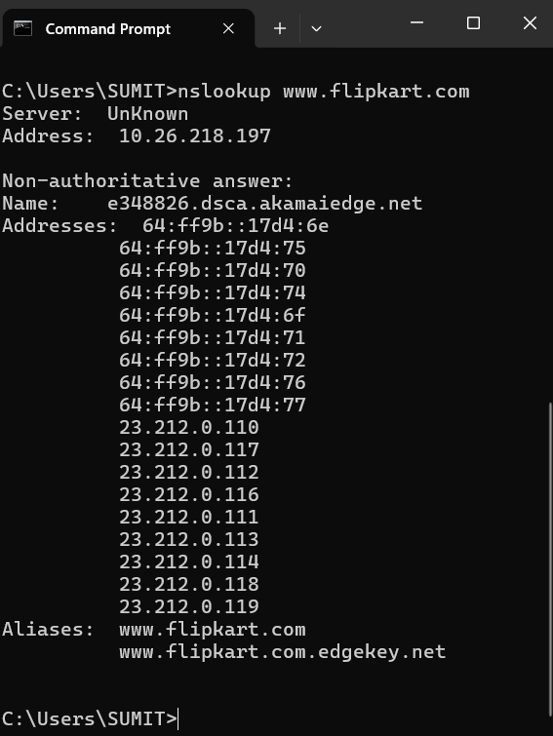

Task 3: HTTP vs. HTTPS Differences & Real-World Example

Feature / Property | HTTP (Hypertext Transfer Protocol) | HTTPS (HTTP Secure)
Security & Encryption | Unencrypted (Plaintext): Data travels in clear text and can be easily intercepted, read, or modified by malicious actors on the network path. | Encrypted (TLS/SSL): Data is encrypted using Transport Layer Security (TLS), protecting sensitive info from eavesdropping.
Default Port Number | Operates on Port 80. | Operates on Port 443.
URL Indicator & Trust | Prefixed with http://; modern browsers flag sites as “Not Secure”. | Prefixed with https:// accompanied by a padlock icon indicating a verified digital certificate.
Real-World App Relying on HTTPS: Paytm (or Zomato / Spotify) relies on HTTPS to ensure that when you input UPI PINs, banking credentials, or personal order details, the session is fully encrypted via TLS, preventing Man-in-the-Middle (MitM) attacks from intercepting your financial data.

Task 4: observe Unvisited Website DNS Query & Response Sequence in Wireshark

When entering a brand-new website URL that has not been visited recently:
- Local Cache Miss: The browser and operating system check their local DNS caches. Finding no matching entry, the OS triggers a recursive query.
- Standard Query to Recursive Resolver: A packet labeled Standard query is sent to your configured DNS server (e.g., your ISP's DNS or 1.1.1.1), asking for the IP address of the new domain.
- Root & TLD Referrals: If the resolver doesn't have it cached, it queries the Root Name Servers, gets directed to the Top-Level Domain (TLD) server (e.g., .com), and is then pointed to the domain's Authoritative Name Server.
- Standard Query Response: The authoritative name server returns a Standard query response packet containing the final IP address mapping back to the recursive resolver, which caches it and hands it to your browser so a TCP handshake can begin.

Task 5: Real-World Scenario for DHCP (Dynamic Host Configuration Protocol)

- Protocol Selected: DHCP (Dynamic Host Configuration Protocol)
- Real-World App Scenario: When you walk into a local coffee shop with your smartphone and open Instagram to check your feed, your phone initially has no network identity. Through the DORA process (Discover, Offer, Request, Acknowledge), the café's Wi-Fi router running a DHCP server automatically assigns your phone a temporary IP address, subnet mask, default gateway, and DNS server within milliseconds. This automated configuration lets your phone connect to the local wireless network and load your Instagram feed instantly without requiring manual network settings.

